Eduardo Cabrera-Lopez

Professor Tawanda Chiyangwa

ITAI 3377

July 22, 2025

A13 Robotic Design and Ethical Analysis Project

**1. Application Domain**

**Domain:** Church – Digital Media & Worship Production Support

Churches regularly ask volunteers or small groups to do hard things like streaming live videos, balancing sound, projecting lyrics, and making visual media. WorshipBot is meant to help church media teams by automating and improving digital production processes. This let’s worship leaders and volunteers focus more on connecting with God and coming up with new ideas.

**2. Robot Design**

**Name:** WorshipBot

**Description:** WorshipBot is a small, AI-powered media production assistant made just for use in churches. It can handle multimedia activities including controlling the camera, monitoring sound, managing the display of lyrics, and live streaming. It can work on its own or with the help of a media director.

**Physical attributes:**

* Height: 3.5 feet
* Sleek cylindrical body with a mounted camera head
* Built-in touchscreen for manual override
* Rolling base for movement between workstations
* Two retractable arms for physical control of devices or cables

**Unique Features:**

* 4K camera with auto-tracking of worship leaders and speakers
* Automatic lighting adjustments
* Wireless sync with lyric projection tools (e.g., ProPresenter)
* Integrated streaming support for YouTube, Facebook, and OBS Studio

**3. Sketch of the Robot**

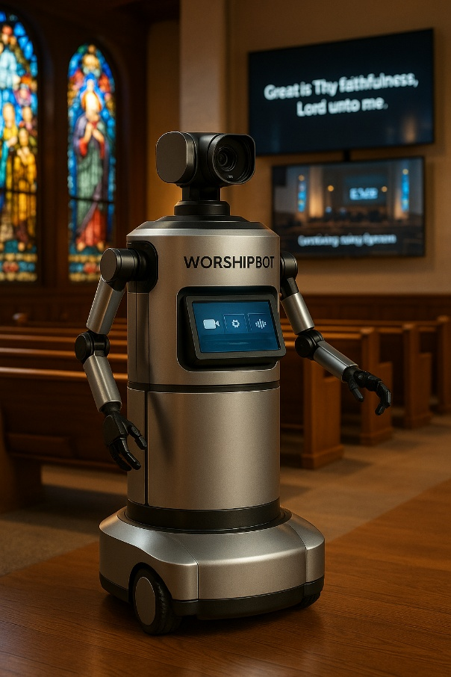

**4. Functionality and AI Integration**

WorshipBot uses AI and robots to improve and automate the quality of live production in real time.

**AI Tasks Performed Autonomously:**

* Switching and tracking cameras based on where the speaker is and how they are moving
* Analysis of background noise and automated EQ balancing
* Making sure that the lyrics slides match up with the worship setlists
* Keeping an eye on and regulating the quality of live streams and platform integration

**Sensors and Inputs:**

* A high-definition camera that can monitor faces and movement
* Microphones that can pick up sound from a certain direction
* LIDAR and sensors for obstacles to keep you safe
* Wireless modules for connecting tools via a network

WorshipBot learns from its surroundings and becomes better at timing and audio and video quality all the time.

**5. Ethical Analysis**

**Privacy Concerns:**  
Recording video and audio of churchgoers could be a privacy issue.

* **Mitigation:** WorshipBot lets you turn off facial recognition, encrypts all recorded video, and gives attendees the option to not participate.

**Safety Concerns:**  
If the system breaks down, it could stop or change the way people worship.

* **Mitigation:** This includes human override, fail-safe shutdown mechanisms, and battery backups to keep things running as smoothly as possible.

**Job Displacement:**  
Automation might make it less necessary for media volunteers.

* **Mitigation:** WorshipBot is meant to be an addition to, not a replacement for, human workers. It's great for small churches with small teams or to help out during events with a lot of people.

**Cultural and Ethical Sensitivity:**  
It could be rude for AI to act inappropriately during a sacred service.

* **Mitigation:** WorshipBot has built-in behavior restrictions that take the situation into account and response procedures that have already been approved.

**6. Research and References**

This design considers the latest developments in AI, robots, and the moral use of technology in religious ceremonies.

**Research Integration:**

* Follows the ethical AI criteria set out by UNESCO (2021) and Nature Machine Intelligence (Jobin et al., 2019)
* Automation that knows what's going on based on Murphy's principles of robotics (2000)
* Talks about real-world media problems that faith-based tech sites like ChurchTechToday talk about

**References:**  
Jobin, A., Ienca, M., and Vayena, E. (2019). AI ethical norms around the world. Nature Machine Intelligence, 1(9), 389–399. https://doi.org/10.1038/s42256-019-0088-2

Murphy, R. R. (2000). An Introduction to AI Robotics. UNESCO. (2021). MIT Press. Advice on the moral use of artificial intelligence. https://unesdoc.unesco.org/ark:/48223/pf0000381137

Fjeld, J. et al. (2020). A systematic review of the literature on AI ethics principles. arXiv:2001.10031. https://arxiv.org/abs/2001.10031

ChurchTechToday. (2023). How AI is changing how churches stream their services. https://churchtechtoday.com